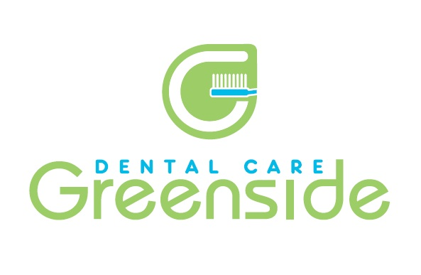
Summer newsletter 2017
Here at greenside not only do we offer the latest dental treatments we also offer facial rejuvenation treatments with Louise.
Louise has completed extra training to provide facial rejuvenation treatments such as Botox, facial fillers, facial skin peels and Redensity.
Redensity is a new concept treatment between facial filing injections and mesotherapy, which redensifies your skin deep down and restores its ability to reflect light. This innovation guarantees a uniform and totally natural result. This treatment can be done at any age when signs of aging appear and develop,
- Tired, drawn features
- Loss of tone and radiance
- Wrinkles and lines
The treatment involves 3 weekly sessions for optimal skin redensification.
Each session is £150 – ask reception for more details or to book a facial rejuvenation consultation with Louise.
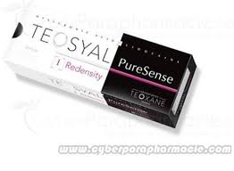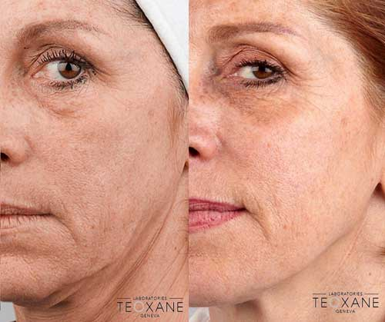

STAFF NEWS
Congratulations to both Chris and Amie celebrating their 40th birthdays in June and July –looking forward to the festivities and fun that the ale trail will bring!!

Our dentist Katie will be working with us on a Friday morning from September as well as Wednesday.
Kirsty is currently studying doing a course in Practice Management through the Yorkshire Deanery. PTO
Andy is still studying towards his Diploma in Endodontics ( Root Canal) which is due to be competed in September when he will then go on to study for his Masters degree. Andy will be seeing the majority of root canal treatments within our own practice and also patients referred in from other dental practices.

Just a reminder about our loyalty scheme – recommend a friend and receive an M & S voucher! Ask reception for more details.

Please can patients keep us up to date with contact details as we send complementary email and text reminders for appointments.
Bank holiday
We will be closed on Monday the 28th August - re open on Tuesday 29th August 8am, for any dental emergencies while we are closed please contact NHS 111
Now in stock ...Black is white whitening toothpaste with activated carbon ...as seen in many glossy magazines!
Black is white whitening toothpaste gently removes discolouration using its unique key ingredient ,activated carbon, without the normal abrading or bleaching associated with many whitening toothpastes.
It is available in two flavour varieties
BLACK IS WHITE-a refreshing lime-flavour
WHITE IS BLACK-still a charcoal toothpaste but with an extra mild taste
Activated Carbon
Activated carbon is responsible for the natural gentleness of this whitening toothpaste. It removes stains without abrading the enamel, absorbing stain particles and gently eliminates them.
On sale in the practice for £22
Special pack contains toothpaste and toothbrush!!
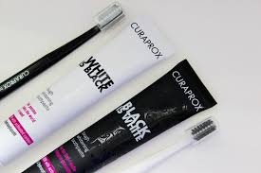
Also in stock we have a selection of toothbrushes by Curaprox – nylon free bristles in fab colours RRP £5.00 our price £3.00!
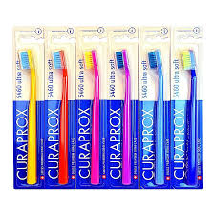
Remember you can follow us on Facebook and twitter for all the latest updates /special offers and also on our website www.greensidedentalcare.co.uk


